Laravel app documentation.

Proksa Levente – WFIM9A

Documentation for my Laravel application.

I have chosen <nonprofit.hu> as my website to copy/improve on.

I have copied/recreated five pages from the original website, which can be found inside the nested menu called „Nonprofit Sites”, where you can expand the „expand me” option and view all pages.



I have used three MVC models, one for the User, one for the Contact form and one for Gallery items. 

The User model stores user data, which is almost the default configuration of Laravel, I’ve only added an enumeration, where you can set yourself to be an administrator, to test out the administrative features.

The Contact for model stores an email address, a name, and a message, which the administrators can read on a separate page, if they are logged in. The option will just appear inside the navigation bar.

The Gallery model stores the file path to the image, the userid which can be mapped to the user that uploaded the picture.

I have used a DB facade to connect the application to MySQL.

I have used ORM to link the images to their respective users. 

I have created migrations while developing the project. 

I have created a seeding to generate test users.

I have a three-level user system, where a non-logged in user is considered as a guest, a logged in user can upload images inside the gallery and the administrators can delete all users’ images and read the contact us messages.

I have used a multi level menu system to house the different subpages of nonprofit.hu.

I have two CRUD applications on the site, one is the upload functionality of the gallery, the second one is the contact form handling.  
The user system could be considered CRUD too, but I’ve used the built-in login system, so I made sure I had two different applications.

I’ve created a photo gallery, where everyone can view photos, logged in users can upload. Regular logged in users can delete their own pictures, administrators can delete every picture.

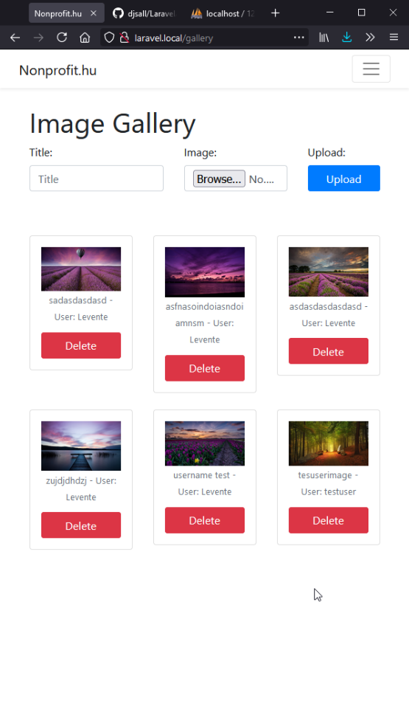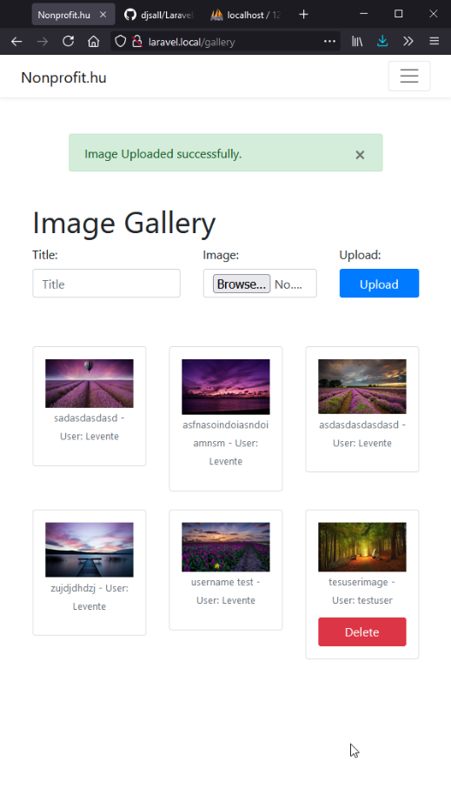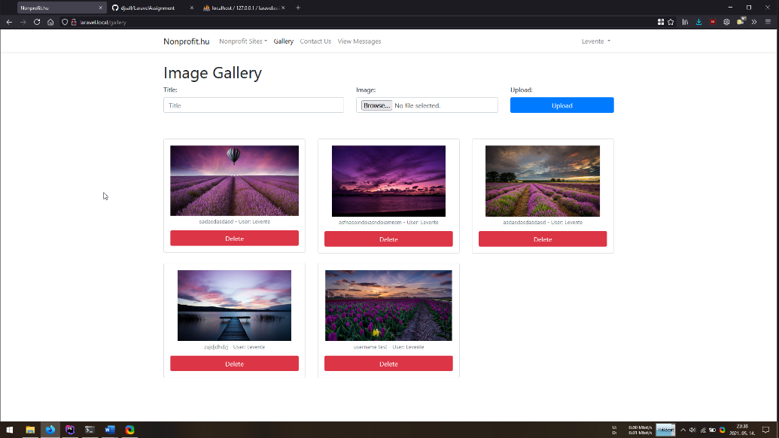

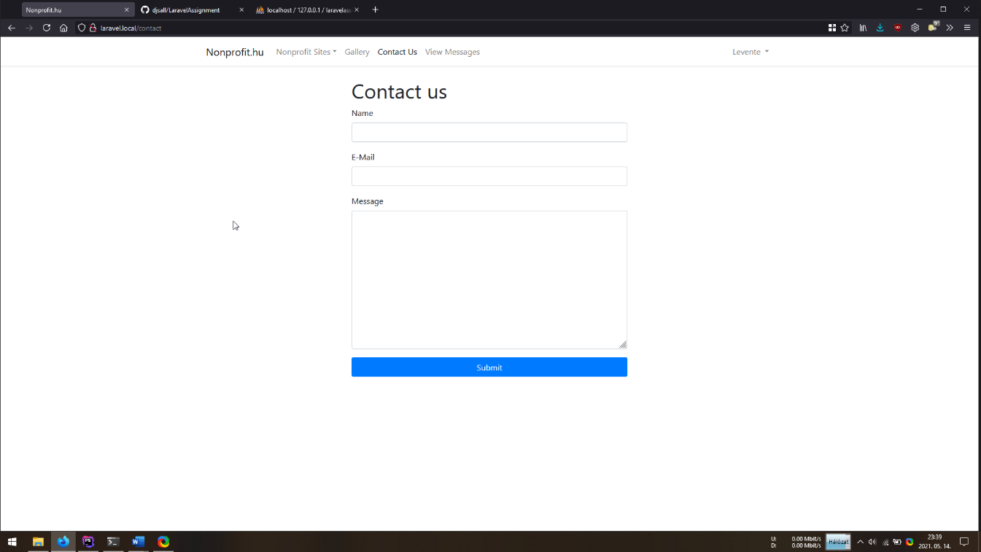I’ve created a contact form, where anyone can submit a message, which administrators can read on the side, and the messages are also saved inside the database.  
The form data is validated on the server side by Laravel’s validator, and uses minimal client side validation, like all fields are required, and the e-mail address has to look like a real e-mail address.



The whole front end of the application is built with bootstrap, using the responsive grid system, so this site should work well with all browser sizes.



I’ve used git version control software to track the progress of development, and also made a GitHub repository, which can be found [here](https://github.com/djsall/LaravelAssignment).

The exported version of the database can be found inside the root folder of the application.